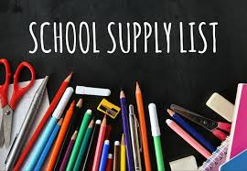

AP U.S. Government
U.S. History
Psychology
Government
Advanced Civics/Economics
- Pens & Pencils
- Notebook Paper
- 3-ring binder (1-1/2 inch)
- Divider Tabs
The following additional items would be greatly appreciated for use in our classroom.
- Tissues
- Colored Pencils & Markers
- Post-It Notes

If you need assistance getting your school supplies, please let me know.

Mrs. Linda Smith

